* Create lambda

* Create table in dynamodb

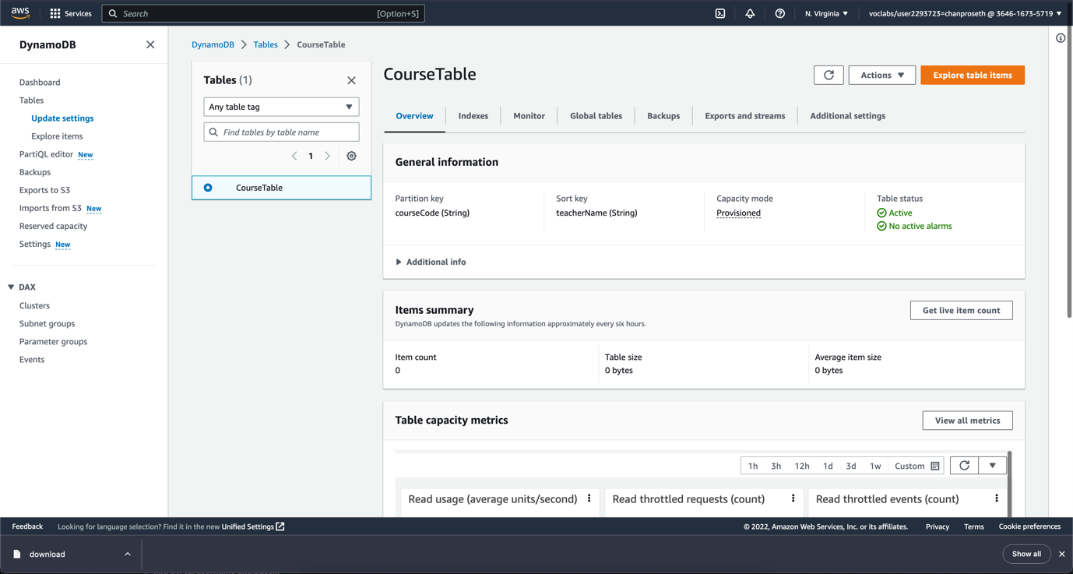

* Add policy

* Add Environment Variable

* Create API Gateway

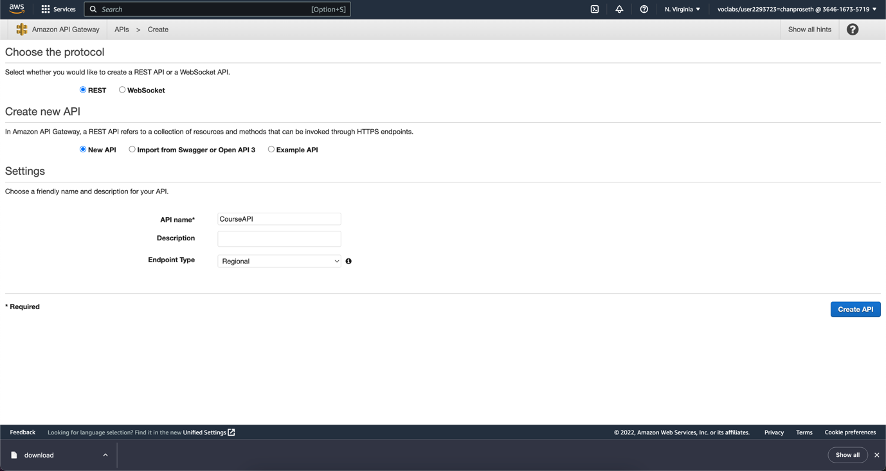

* Create resource Path

* Create API method

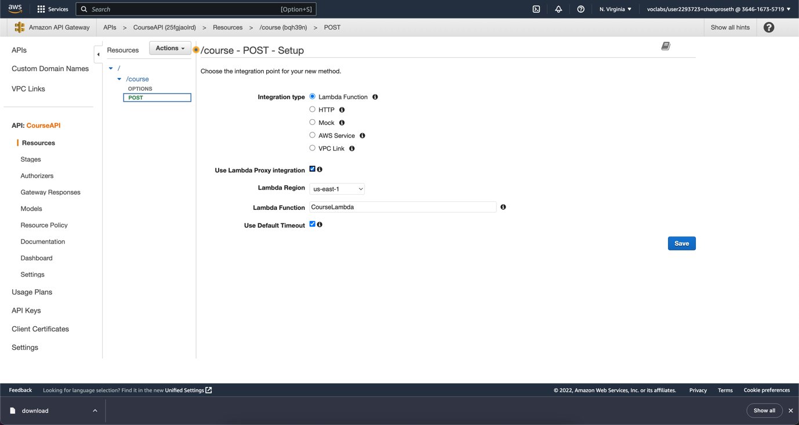

* Test in API gateway

* This policy allow api gateway to access lamda

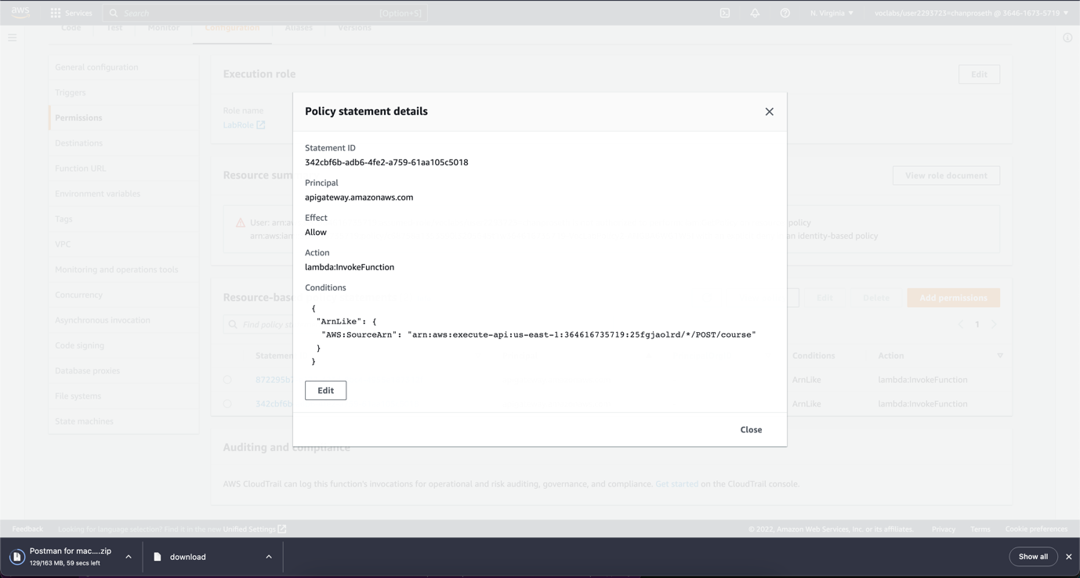

* Check in cloudwatch

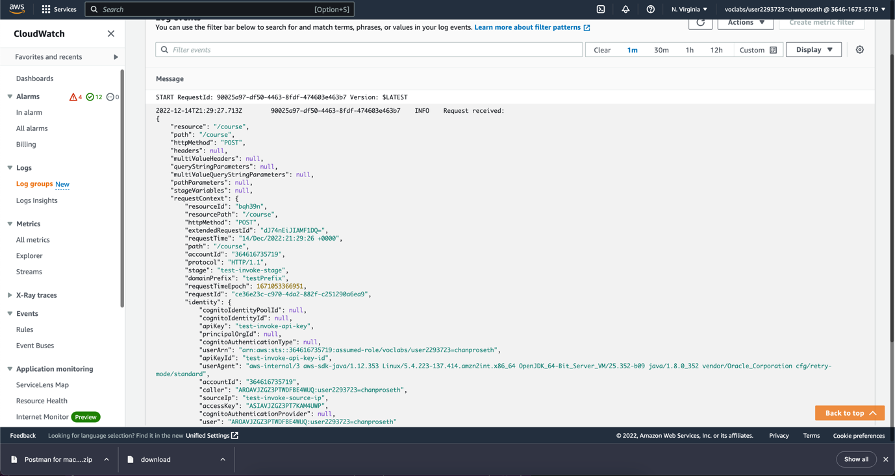

* deploy

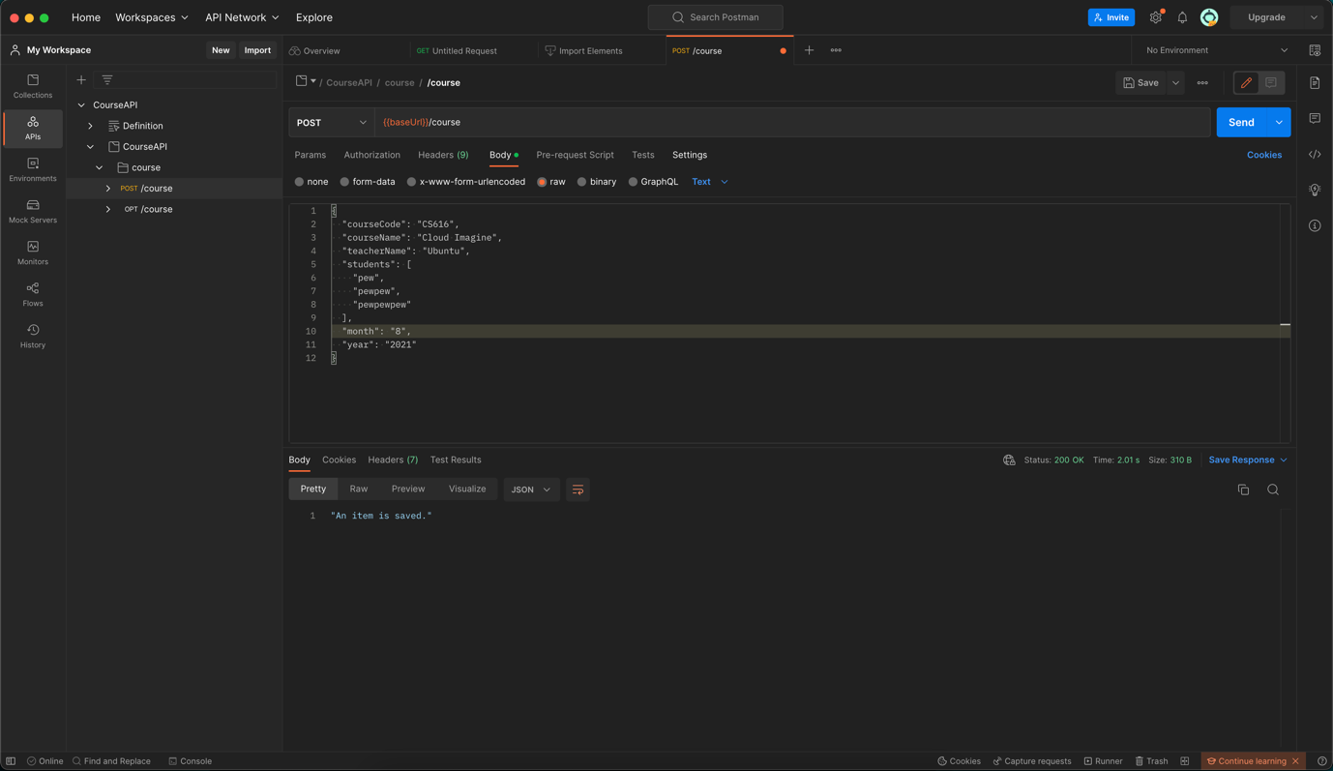

* Create Userpool

* Must add ALLOW_USER_PASSWORD_AUTH to Authentication flows to use email and password to login
* Also get the ClientID for use in command

* Use this command to get token

aws cognito-idp initiate-auth --auth-flow USER_PASSWORD_AUTH --client-id 1o8f4knm7oo7v31vnpm2s9lq0k --auth-parameters USERNAME=kchanproseth@gmail.com,PASSWORD=123456 -- region us-east-1

* Go to Api Gateway
* Create new Authorizer

* Add Authorization for Post and Get API

* Create method for get course/{courseName} and deploy latest

* Test get all and post with Authorization

